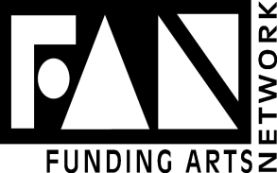

If you are interested in joining any FAN committees, please send the form below to: Funding Arts Network, VP Membership, P.O. Box 331864, Miami, FL 33233-1864
Choose a Committee (required):
Cultural Camaraderie__________ Communications_______ Membership_______________
Luncheons_________ Screening______
For Screening, please choose your first two discipline choices: Dance, Theater, Visual, Orchestral Music, Vocal Music
Discipline 1st Choice**(required)____________________________________________
Discipline 2nd Choice**(required)______________________________________
First Name (required)_________________________________________________________
Last Name (required)____________________________________________________________
If Corporate Member please provide business name_____________________________________

Email Address (required)______________________________________________________
Mailing Address___________________________________________________________
_________________________________________________________________
City___________________________________________________
State_________________________________________ Zip Code___________________________
Phone_________________________________________ FAX____________________________________

Best Time to Call__________________________

