If your use of our logo requires a larger file size or a different file format please email us: [webmaster@fundingartsnetwork.org](mailto:lisajhoffman@att.net) and we will accommodate your needs!

RGB: Fan-logo-2015-color-rgb.jpg

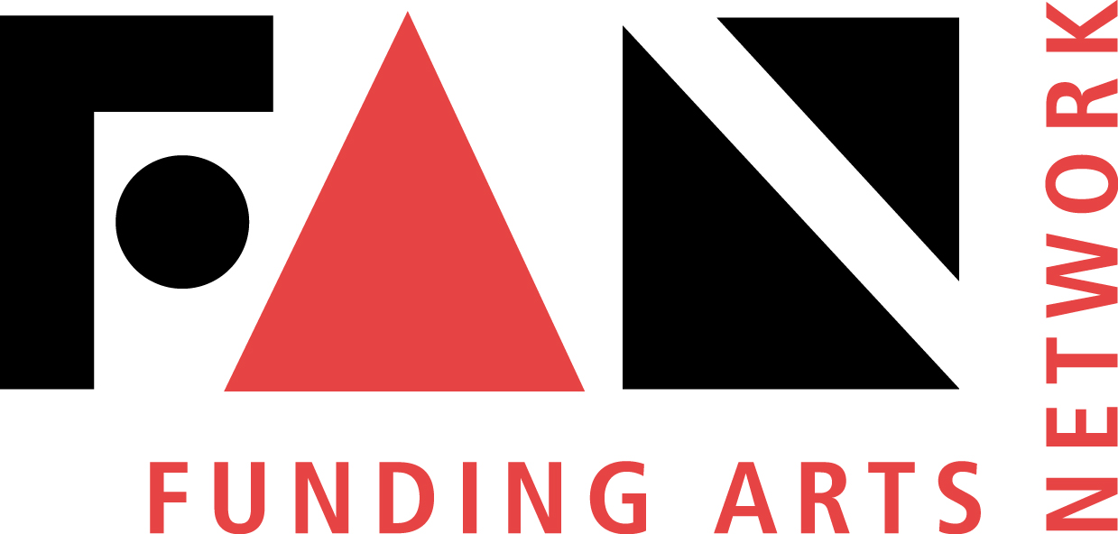

GRAYSCALE: Fan-logo-2015-bw.jpg



CMYK: Fan-logo-2015-color-cmyk.jpg

